FINITE AUTOMATON (DFA) FOR A SECURITY AND ACCESS CONTROL SYSTEM

Denis Muthuri C026-01-0770/2024
Mung’atia Collins Mugendi C026-01-2574/2024
Hopecalvin mutharimi C026-01-0769/2024
Joakim Kiugi C026-01-0800/2024

1. Introduction
Security and access control systems are widely used to restrict unauthorized access to sensitive resources. These systems typically require a sequence of authentication steps such as presenting a card and entering a Personal Identification Number (PIN).
This project presents the design of a Deterministic Finite Automaton (DFA) that models a simplified access control system. The DFA is implemented and visualized using JFLAP.

2. Objective
The objectives of this project are:
- To design a DFA representing a security system
- To model authentication using card and PIN verification
- To simulate valid and invalid access attempts
- To understand the application of automata theory in real-world systems

3. System Description
The system operates in the following sequence:
- The system starts in a locked state (q0)
- A user presents a card (C)
- The system moves to card presented state (q1)
- The user enters a PIN (P)
- The system moves to PIN entered state (q2)
- If the PIN is verified (V), access is granted
- The system transitions to unlocked state (q3)
If the process is interrupted or incorrect transitions occur, the system returns to the locked state.

4. DFA Formal Definition
The DFA is defined as:
M = (Q, Σ, δ, q0, F)

4.1 States (Q)
- q0 → Locked (Start state)
- q1 → Card presented
- q2 → PIN entered
- q3 → Unlocked (Accept state)

4.2 Alphabet (Σ)
- C → Card presented
- P → PIN entered
- V → Verification (correct PIN)
- T → Termination/Reset

4.3 Start State
- q0

4.4 Accept State
- q3

4.5 Transition Function (δ)
Current State | Input | Next State
q0 | C | q1
q1 | P | q2
q2 | V | q3
q2 | T | q0
q1 | T | q0
q0 | T | q0

5. Description of the DFA
The DFA begins at q0, representing a locked system. When a card (C) is presented, the system transitions to q1. Upon receiving a PIN (P), it moves to q2.
At state q2, the system checks the correctness of the PIN:
- If verified (V), the system moves to q3, granting access
- If terminated or incorrect (T), the system resets to q0
The accept state q3 represents a successfully unlocked system.

6. Diagram Explanation
The diagram consists of four states connected by labeled transitions:
- A transition from q0 to q1 labeled C (card insertion)
- A transition from q1 to q2 labeled P (PIN entry)
- A transition from q2 to q3 labeled V (verification success)
- Reset transitions labeled T returning the system to q0
This structure ensures that only the correct sequence leads to access.

7. Testing and Results

Test Case 1: Valid Input
Input:
C P V

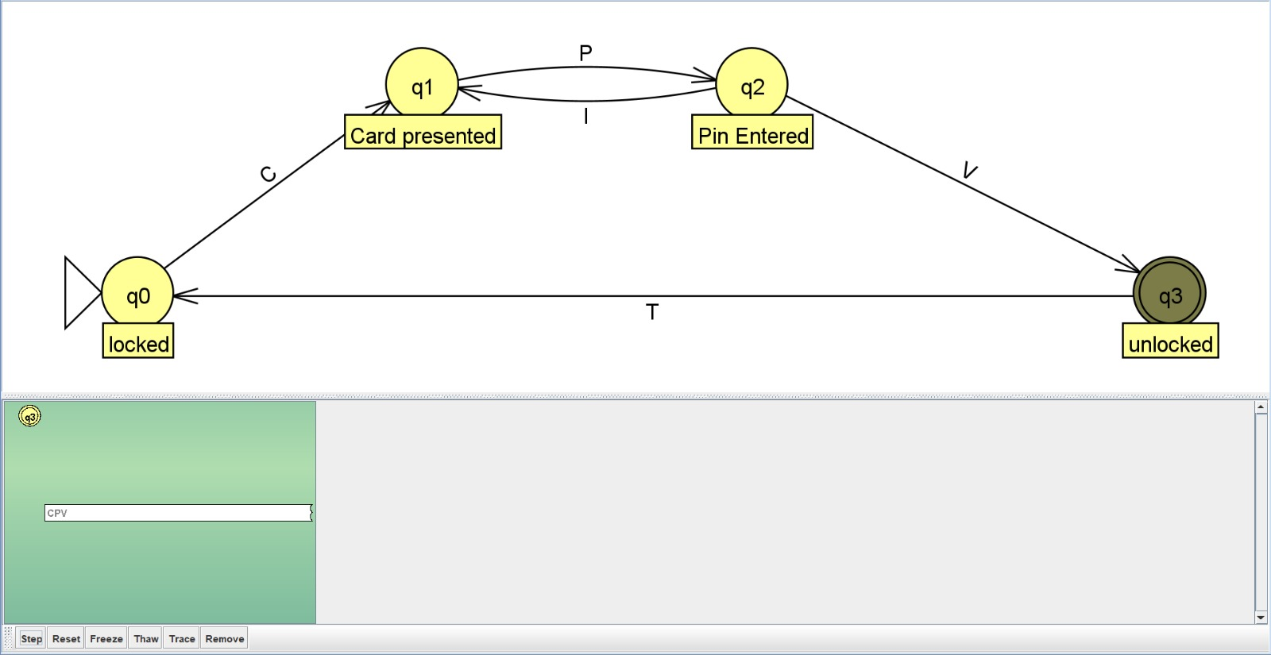
State transitions:
- q0 → q1 → q2 → q3
Result:
- Accepted (Access Granted)

Test Case 2: Invalid Input
Input:
C P T
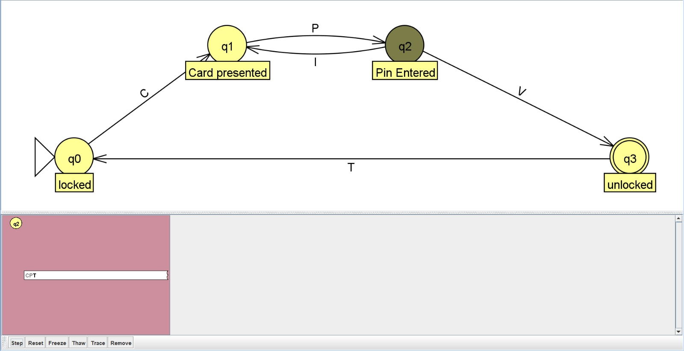
State transitions:
- q0 → q1 → q2 → q0
Result:
- Rejected (Access Denied)

8. Discussion
The DFA accurately models a real-world authentication system. It ensures:
- Sequential validation of inputs
- Immediate reset on incorrect input
- Deterministic behavior (one transition per input per state)
The system enforces strict access control by only accepting the correct sequence of inputs.

9. Conclusion
This project demonstrates how a DFA can be used to model a security and access control system. The design ensures that only users who follow the correct sequence of authentication steps gain access.
The implementation highlights the practical application of automata theory in designing secure systems.

10. References
- JFLAP Software Documentation
- Theory of Computation Lecture Notes
- Automata Theory textbooks

